* **Activity Diagrams-:**
* Activity diagrams are graphical representations of Workflows of stepwise activities and actions with support for choice, iteration and concurrency.In the Unified Modeling Language, activity diagrams can be used to describe the business and operational step-by-step workflows of components in a system. An activity diagram shows the overall flow of control.



**Class diagram:**

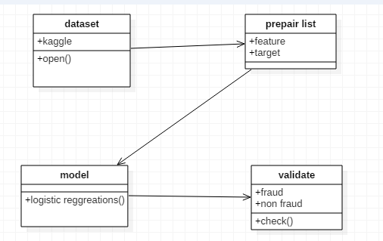

**Component diagram:**



**Deployment diagram:**



* **Sequence Diagram:**
* A **sequence diagram** in Unified Modeling Language (UML) is a kind of interaction diagram that shows how processes operate with one another and in what order. It is a construct of a Message Sequence Chart. A sequence diagram shows, as parallel vertical lines ("lifelines"), different processes or objects that live simultaneously, and, as horizontal arrows, the messages exchanged between them, in the order in which they occur. This allows the specification of simple runtime scenarios in a graphical manner.

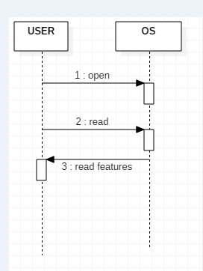

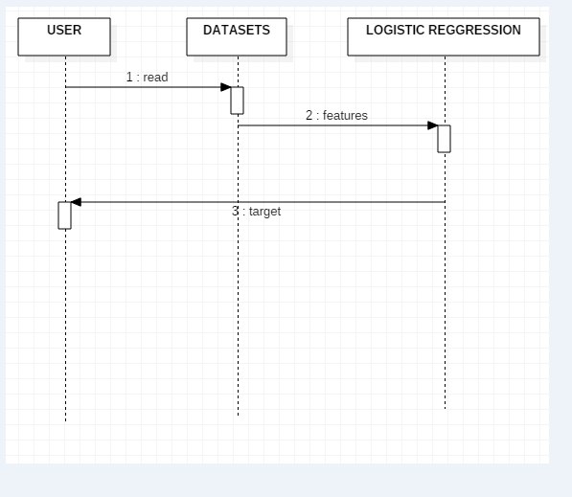

**Usecase diagram:**

* UML is a standard language for specifying, visualizing, constructing, and documenting the artifacts of software systems.
* UML was created by Object Management Group (OMG) and UML 1.0 specification draft was proposed to the OMG in January 1997.
* OMG is continuously putting effort to make a truly industry standard.
* UML stands for **U**nified **M**odeling **L**anguage.
* UML is a pictorial language used to make software blue prints



**Data flow diagram:**

